QA Test Cases and Checklist and Bug Reports – AutomationExercise

# Checklist for Add to Cart Function

### 1. ****UI Elements****

**1.1.** The "Add to Cart" button is visible and correctly labeled.

**1.2.** Product image, name, price, and details are displayed near the button.

### 2. ****Basic Functionality****

**2.1.** Clicking "Add to Cart" adds the correct product.

**2.2.** Quantity updates when the same product is added again.

**2.3.** The cart displays the correct total quantity and price.

**2.4** User cannot add an extremely large quantity (e.g., 10,000,000 units) to the cart.

**2.5** User can change product quantity directly in the cart (increase/decrease).

### 3. ****Behavior & State****

**3.1.** Product stays in the cart after page refresh.

**3.2.** The cart is empty by default when no items are added.

**3.3.** Removing an item updates the total correctly.

### 4. ****Input Validation****

**4.1.** Out-of-stock items cannot be added.

**4.2.** Negative quantities cannot be added.

### 5. ****Edge Cases****

**5.1.** Cart persists if the user is not logged in (if expected).

**5.2.** Multiple tabs adding items are handled correctly.

### 6. ****Feedback & UI Updates****

**6.1.** Visual confirmation is shown (popup, animation, badge update).

**6.2.** Cart icon updates immediately with the number of items.

**6.3.** Success/failure messages are clear and user-friendly.

### 7. ****Performance****

**7.1.** The "Add to Cart" action works without delay.

**7.2.** Cart loads quickly even with 10+ items.

# Test Cases

|  |  |  |  |  |  |
| --- | --- | --- | --- | --- | --- |
| Test Case ID | Title | Steps | Expected Result | Actual Result | Status |
| TC01 | The "Add to Cart" button is visible and correctly labeled. | **Step 1:** Navigate to the product page.  **Step 2:** Check if the "Add to Cart" button is clearly visible.  **Step 3:** Ensure the button is labeled correctly ( "Add to Cart"). | The button is visible and correctly labeled. | The button is visible and correctly labeled. | Passed |
| TC02 | Product Information Display | **Step 1:** Navigate to a product page.  **Step 2:** Check if the product image, name, price, and details are displayed near the "Add to Cart" button. | Product image, name, price, and details are visible. | Product image, name, price, and details are visible. | Passed |
| TC03 | Adding Product to Cart | **Step 1:** Go to the product page.  **Step 2:** Click on the "Add to Cart" button. | The product is added to the cart. | The product is added to the cart. | Passed |
| TC04 | Update Quantity | **Step 1:** Add the same product multiple times to the cart.  **Step 2:**Verify if the product quantity in the cart is updated accordingly. | The quantity of the same product is correctly updated. | The quantity of the same product is correctly updated | Passed |
| TC05 | Add extremely large quantity of a product (e.g., 10,000,000 units) | **Step 1:**Navigate to a product page.  **Step 2:**Manually input a very large number into the quantity field (e.g., 10000000).  **Step 3:**Click the "Add to Cart" button. | System prevents the addition.Either an error message is shown or the input is limited to a maximum allowed number. | Pop-up appeared: "Your product has been added to cart"  And we see 1000000 items in the cart. | ! |
| TC06 | Change Product Quantity in Cart | **Step 1:**Navigate to the cart page.  **Step 2:**Locate the quantity input for the product.  **Step 3:**Attempt to change the quantity (e.g., from 4 to 2, or from 4 to 5).  **Step 4:**Observe if the quantity updates and the total price recalculates. | Observe if the quantity updates and the total price recalculates. | The user cannot click on the quantity field and cannot change the quantity of the item | ! |
| TC07 | Product Persistence After Refresh | **Step 1:**Add a product to the cart.  **Step 2:**Refresh the page. | The product remains in the cart after refresh. | The product remains in the cart after refresh. | Passed |
| TC08 | Empty Cart by Default | **Step 1:**Navigate to the cart page.  **Step 2:**Check if the cart is empty by default (when no items are added). | The cart is empty when no items are added. | The cart is empty when no items are added. | Passed |
| TC09 | Remove Item Updates Cart | **Step 1: Add a product to the cart**  **Step 2: Remove the product from the cart** | The cart total is updated afterremoving the item | The cart total is updated afterremoving the item | Passed |
| TC10 | **Prevent Adding Out-of-Stock Item** | **Step 1: T**ry to add an out-of-stock item to the cart. | The item cannot be added to the cart (button is disabled or an error message is shown). | Goods of this type are not displayed on the site | Passed |
| TC11 | Prevent Negative Quantity | **Step 1:**Try to enter a negative quantity for a product in the cart. | The system rejects negative quantities. | Pop-up appeared: "Your product has been added to cart"  And we see “-1” items in the cart. | ! |
| TC12 | Cart Persistence Without Login | **Step 1:**Add a product to the cart without logging in. | The cart persists. | The cart persists. | Passed |
| TC13 | **Simultaneous Add-to-Cart from Different Tabs** | **Step 1:**Open multiple browser tabs.  **Step 2:**Add the same product to the cart in each tab. | The cart handles multiple simultaneous additions correctly. | The cart handles multiple simultaneous additions correctly. | Passed |
| TC14 | Visual Confirmation on Add | **Step 1:**Add a product to the cart. | A visual confirmation (popup, animation, badge update) appears. | pop-up window with confirmation of adding an item to cart | Passed |
| TC15 | Immediate Cart Icon Update | **Step 1:**Add a product to the cart. | The cart icon updates with the correct number of items immediately. | The shopping cart icon is not updating at all | ! |
| TC16 | Success/Failure Message | **Step 1:**Add a product to the cart. | A success or failure message is displayed clearly. | A success or failure message is displayed clearly. | Passed |
| TC17 | **Smooth Add to Cart Action** | **Step 1:**Add a product to the cart. | The action happens without delays or lag. | The action happens without delays or lag. | Passed |
| TC18 | Cart Loads Quickly | ****Step 1:**** Add 10 or more products to the cart.  **Step 2:** Open the cart. | The cart loads quickly even with 10+ items. | The cart loads quickly | Passed |

Bug roports

### ****Bug Report #1****

**Title:** Prevent Negative Quantity

**Steps to Reproduce:**

1. Navigate to a product page.(<https://automationexercise.com/product_details/1>)

2.Try to enter a negative quantity for a product in the cart.



3.Enter Add to cart and see “Added!”

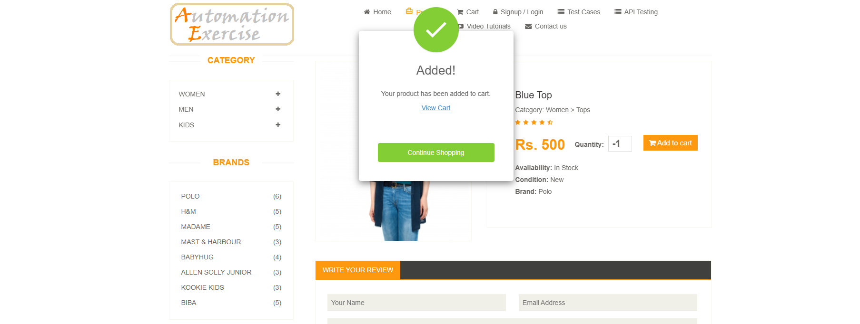

4.Click “View Cart” and we see that the quantity of goods is “-1”

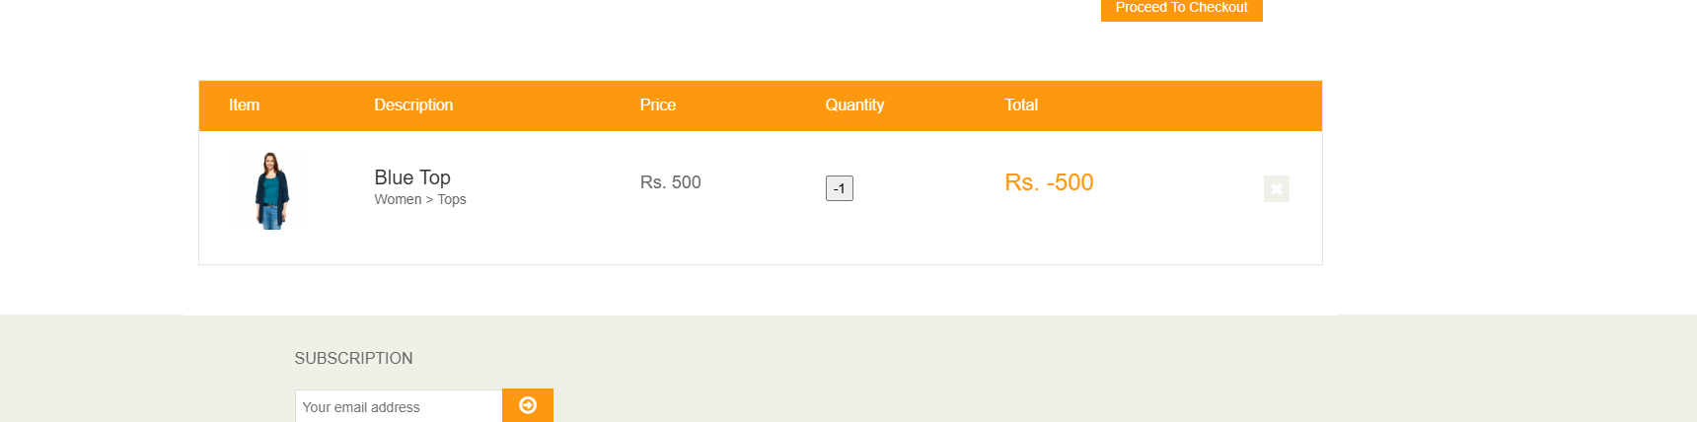

**Expected Result:**  
The system rejects negative quantities.  
**Actual Result:**  
The system allows negative quantity of items in the cart.  
**Severity:** Hight

### ****Bug Report #2****

**Title:** Add extremely large quantity of a product (e.g., 10,000,000 units)

**Steps to Reproduce:**

**1.**Navigate to a product page.(<https://automationexercise.com/product_details/1>)

**2.**Manually input a very large number into the quantity field (e.g., 10000000).

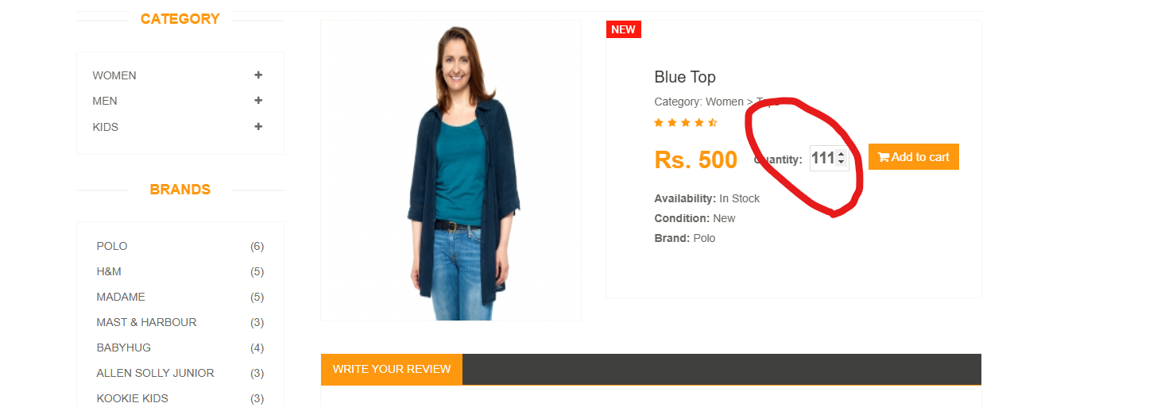

3.Enter Add to cart and see “Added!”

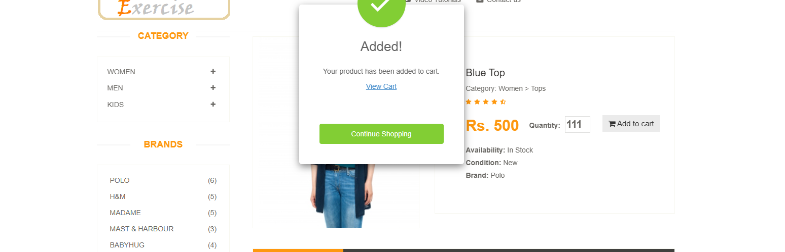

4.Click “View Cart” and we see that the quantity of goods is “10000000”

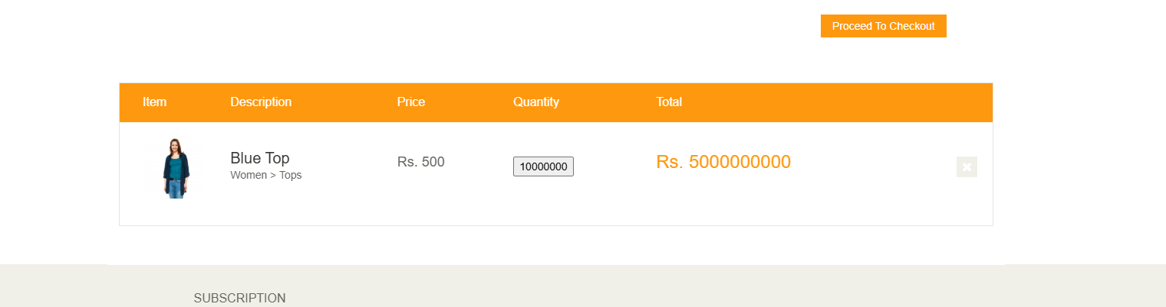

**Expected Result:**  
System prevents the addition.Either an error message is shown or the input is limited to a maximum allowed number.

**Actual Result:**  
The system does not make any restrictions on the number of items in the cart

**Severity:** Hight

### ****Bug Report #3****

**Title:** Add extremely large quantity of a product (e.g., 10,000,000 units)

**Steps to Reproduce:**

**1.**Navigate to the cart page.

**2.**Locate the quantity input for the product.

**3.**Attempt to change the quantity and we see that we can't change the quantity of product.

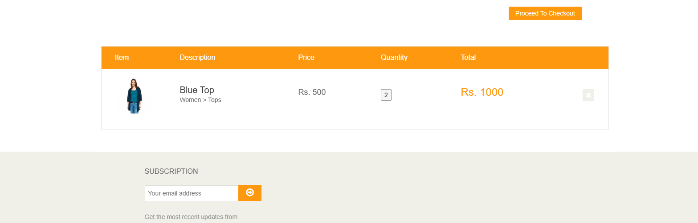

**Expected Result:**  
Observe if the quantity updates and the total price recalculates.  
**Actual Result:**  
The user cannot click on the quantity field and cannot change the quantity of the item

**Severity: Low**

### ****Bug Report #1****

**Title:** Prevent Negative Quantity

**Steps to Reproduce:**

1. Add a product to the cart.
2. The shopping cart icon is not updating at all 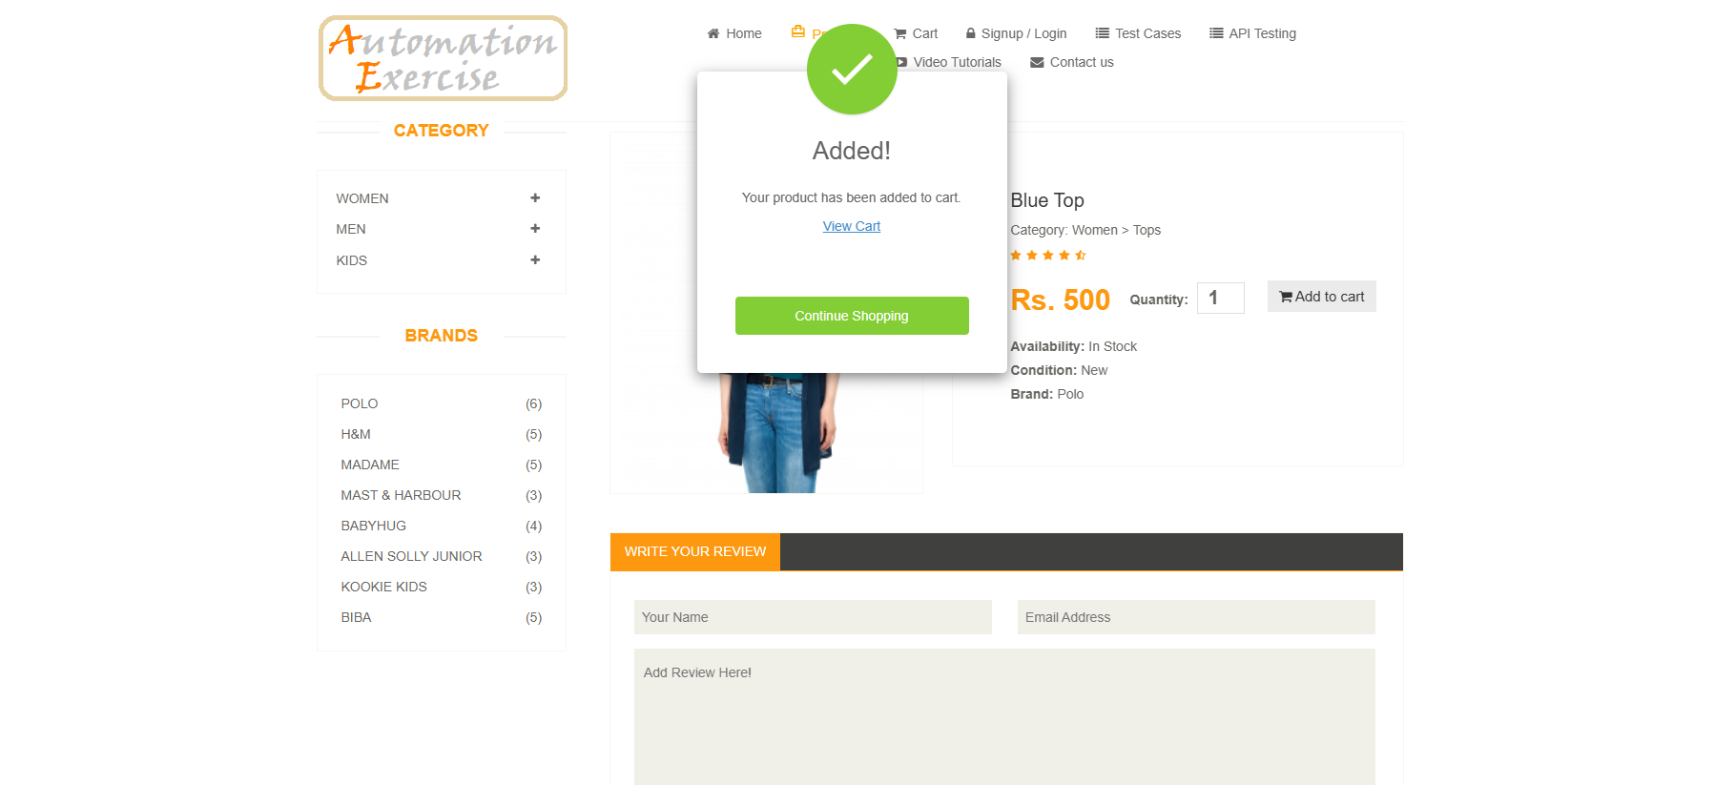

**Expected Result:**  
The cart icon updates with the correct number of items immediately.  
**Actual Result:**  
The shopping cart icon is not updating at all

**Severity:** Low